AOPM Open Source System On SDLC Theory
Mr. Yaoguang. Luo
Liu Yang Deta Software Development Limited Company, Hunan, China,
313699483@qq.com

Outline: Mr. Xuesen. Qian once said: Science Is A Titan System, as an opensource software conception. this topic implements a software interaction theory of SDLC for Analysis, Operation, Process and Management-- AOPM. Also, this is a tiny paper where easy to show more idyllic landscapes of using Deta open source projects. Not only for web system, also for mobile and desktop platform. The final goal is makes complex project to simple. Ok let go and the next steps.

Keywords: SDLC, AOPM, VPCS, WEB, Concurrent, Open Source, Interaction, Management, Automation

Introductions

Recently my colleagues take more care on the SDLC evolution of open source software engineering, for each project they undertake on where it cost a lot of times, that’s for my job, continuing found out a high effect, simple and clear theory of SDLC what be my main task now. after imagination and logic recursion, the key is an optimization of ordinary SDLC such as water fall. First time for makes an introduction for waterfall of SDLC? The author’s explanation likes sequence linked list of component nodes. With Deta projects here contains four aspects at Figure1-1. And my explanation of opensource as belows

Topic: Ten Definition of The Open Source, OSS Book Reading Note
In this paper, through a premise: the contrast between the copyright and the contract. the author talks a comprehensive introduction of the definition of the open source code. The role of the open source licenses, which is to allow the work permit under the non-exclusive business. Not only does it mean that the source code be visited by the public user, and also meets another 10 conditions as follows. The first point: the open source software allows the free reusable distribution. The license must not restrict that any party sell or give away the software. At the same time, it can't get the sold fees and other fees for this software. The second point: the program must include the full of source code. The license do not allowed that getting the source code from any specific forms of the production. The license assure that no one can intentionally to confuse the source code. At the same time, the users have the right to access to the source code under this license. The third point: which talks about the rights of the derivative work. The license must allow the work-modification and the new-work -derivation . those new's are published under the same license. The fourth point: the integrity of the source code. Licenses and the integrity of permits,which may limit the distribution of the form of the modified source code. The fifth point: license does not discriminate against any specific groups and individuals. The sixth point: license does not limit the use way of any particular field scheme. At the same time, the license can't limit the use way's flexibility and reliability. The seventh point: the distribution of the license. Distribution solutions do not need additional license.The eighth point: the license must not specific to the product. The redistribution of the software do not dependent on the program. The ninth point: license may not restrict other software. This license may not restrict the publishment of the software. The distribute software will be build by using open source. The end point: license rights is neutral. So, it effective limits that the freedom of the code transmission. In other words, it provides the preventive measures.

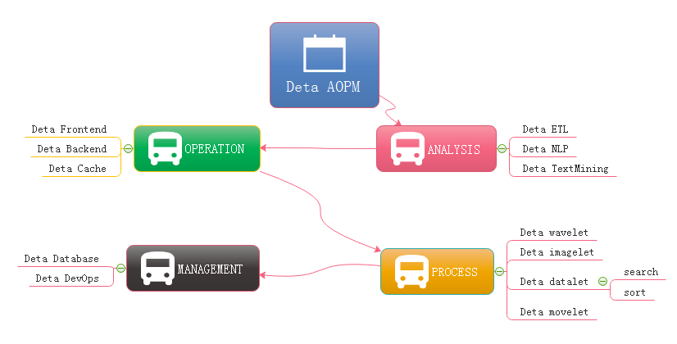
Figure 1-1 AOPM Applications with SDLC
Evolutions
Last year I was asked by so many engineers, almost the same question: how have you make so many projects during the year of 2018? My answer is absolutly: connection. Always, with connection, I got lots of fantacy expirations on the projects where I undertook. My projects all are lower basic technical factors, with connections, what support me the necessary energy for continuing development on my projects. What means connection? Is an internal union bridge between my projects. For example Deta NLP and Deta ETL, they both have the same attributes such as AI, Analysis and Data etc, with this connections, my tasks became more dynamically. Everytime before I made a dicition of priority level of my projects, I thought the connection first, Deta projects totally can be serparated into three dimentions. Frontend Backend and Storage, as the Figure 1-2, the connection of Deta projects is WEB AI, now is a Bazaar requirement, but we will easy to make estinmation of it’s future, toward to Cathedral.
Topic: Cathedral and the Bazaar, OSS Book Reading Note
Cathedral and the Bazaar, this article has a profound implication, the author is a computer scientist with extensive experience. We can say that he is one of the the early code and program contributors in the Unix system. This article describes the Linux development with the revolutionary road, as the process from the bazaar to the cathedral. First, the author tells the contrast between Unix and Linux: now Unix is still popular around the world. Its rigorous structure and contribution to science, let it is proud of the same dignity as a church. Linux looks like a noisy bazaar, the code work in various countries around the world, to solve their own problems and arguing in the forums and communities. Like a bazaar. Then, author points a internal factors to get a in-depth discussion: Unix reason why it has the church's authority, because its development has always been tailor-made by the world's most senior and most eminent researchers and software scientists. Although the discussion, because of the nature of the project-oriented, so that Unix has been applied still to today. Even of the unreasonable original design, through decades of use, engineers have become accustomed to this experience now, there fore, we are called transcendental. which makes Unix feel like a cathedral. The birth of the Linux was different, survival in an all-spittle environment. Every update, are implemented in controversial circumstances. The crowd here, are huge number of scientists, or writers,or code workers or merchants, their common ideal is that make Linux development meets the needs of all groups. Similar a huge bazaar. The author commenced a leno-vo, a conclusion that Linux will eventually beat Unix, Unix gets the range of fresh blood is less than the Linux' s, also the number of the Unix team members is less than the Linux' s. Unix customers and employees are aging. But Linux development more in line with the user of the needs. Its own development is to establish a relationship on this demand and requirement. Linux is young now. Summary, UNIX and Linux development option is the two kinds of very different road. These processes and methods to determine the fate of the two kinds of software development. Of more optimistic about Linux because it is better adapted to the environment.
At figure 1-2, Deta open source main based on AI domain, it already formed as an ecology system, go ahead to the application, thanks.
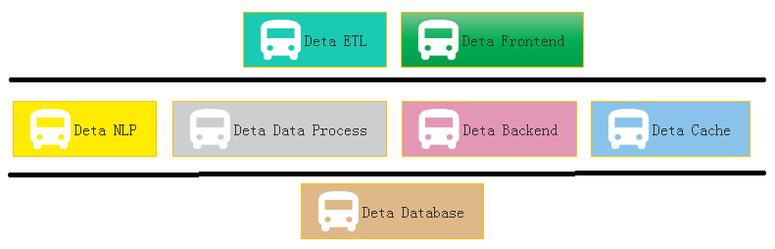
Figure 1-2 Sections of Deta Projects Group
Applications
One question is my friend asked me does Deta support the e-commence logic? Definitly! Please see the Figure 1-3, this is a classic horizontal deployment sample of the real word. Alibaba, Amazon, Ebay and JD etc, all based on this technology, instead of Spring, Deta can be the next generation of technology.
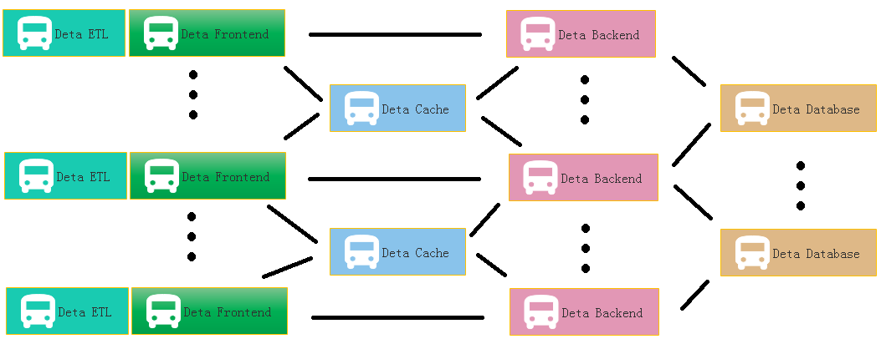
Figure 1-3 Deta WEB Projects System
At Figure 1.4 is a real sample for web Devops by using Deta Open Source.
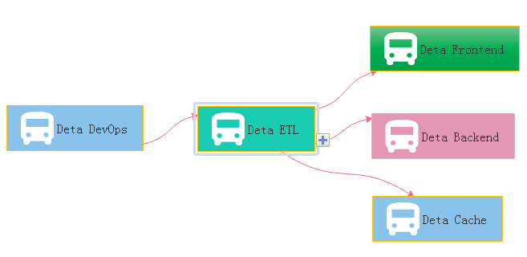
Figure 1-4 Deta DevOps Projects System
References

SDLC: “”, https://en.wikipedia.org/wiki/Systems_development_life_cycle
VPCS: Yaoguang. Luo, https://github.com/yaoguangluo/VPCS_Theroy/blob/master/VPCS-Method_V1.1.pdf
OSS Book: Eric Steven Raymond, 《The Cathedral and the Bazaar》

Acknowledgement

Thanks GIT Hub, Eclipse.org, Microsoft, Apache and Java. Google, Angular, JQUERY, Bootstrap, JSON, Oracle.
Thanks from the bottom of my deep heart.
Thanks to my family, my colleagues, and my customers. Common!

